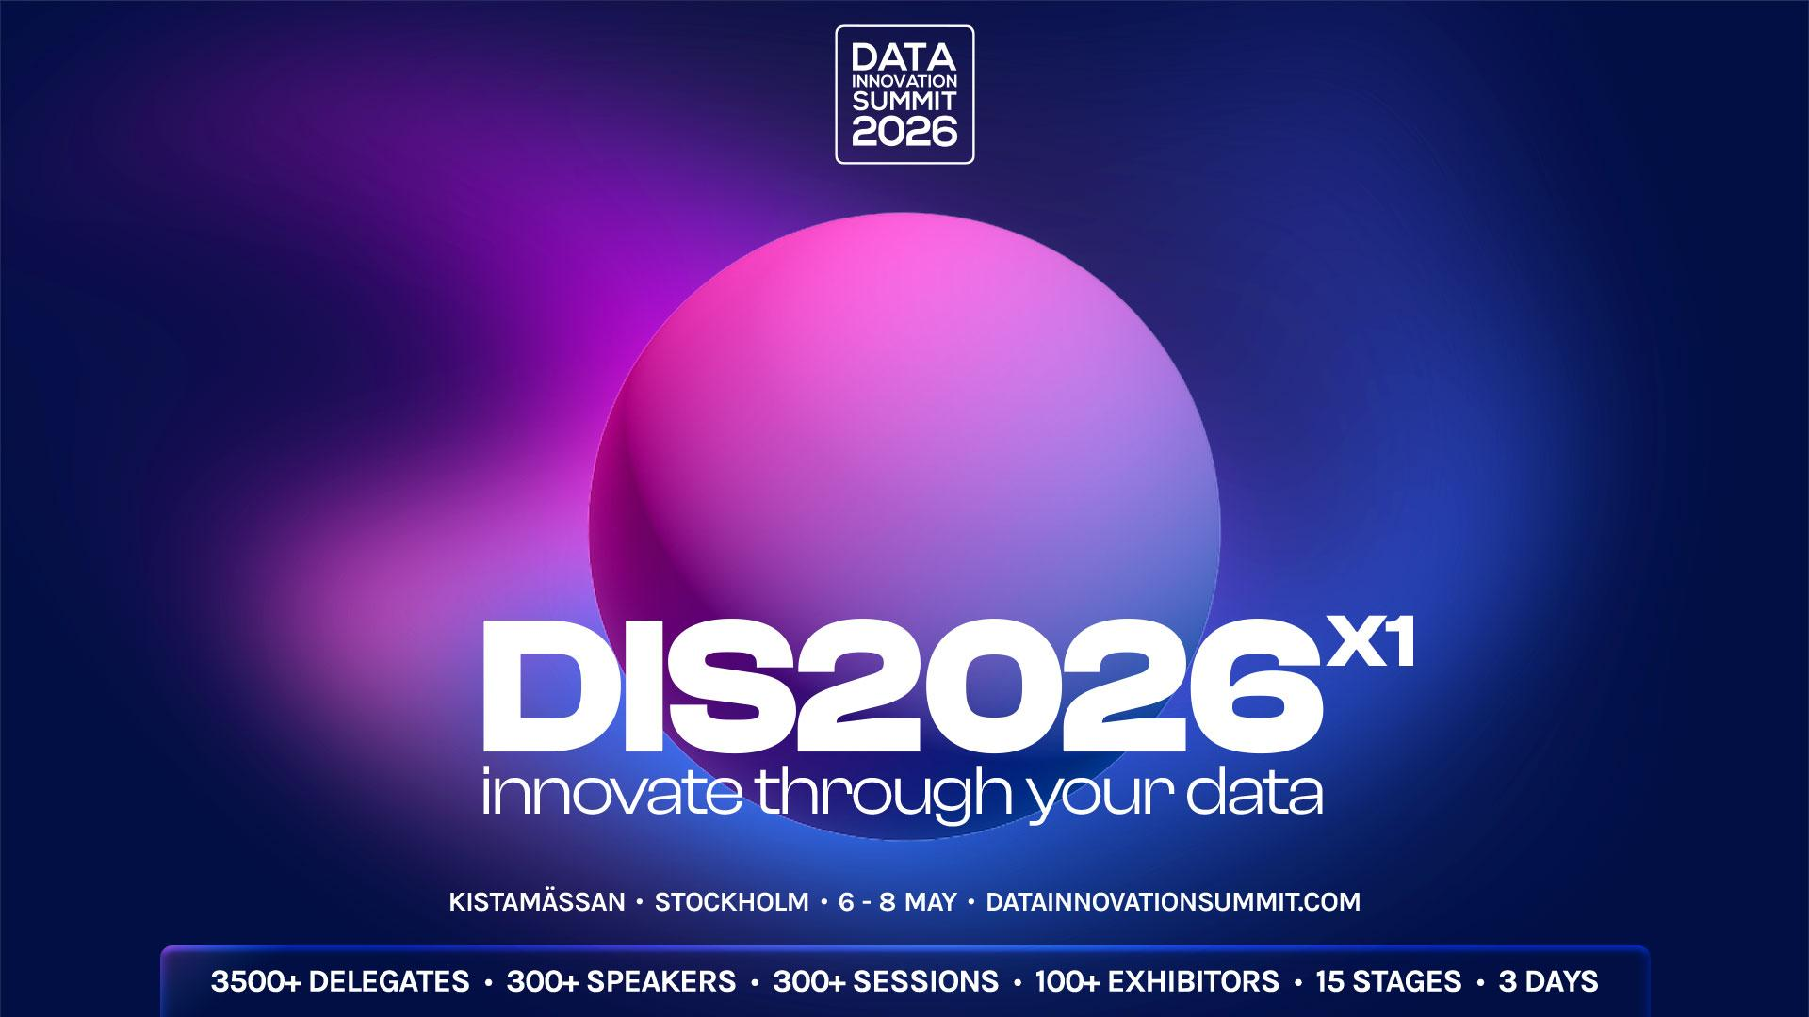
Dear [your manager’s name],
I’d like to attend the Data Innovation Summit 2026 (DIS2026X1) on May 6–8 in Kistamässan, Stockholm, Sweden. Although the event offers both online and onsite formats, I strongly prefer attending in person to maximize the learning experience.
The Data Innovation Summit is the biggest Applied Data & AI event in the Nordics, and one of the most influential practical Data/AI events globally, where the newest and the most innovative Data/AI projects, strategies, and technologies are presented. The 11th Edition of the event features 350 speakers and is expected to host 3500+ delegates and online viewers from more than 50+ countries, representing over 1000 companies. This comes after close to 2000 global practical case studies presented in the past 10 editions.
The event brings together the most innovative minds, enterprise practitioners, technology providers, startup innovators and academics, working with Applied Data Innovation, Data Science, Big Data, ML, Applied AI, Generative AI, Agentic AI, Data Management, Data Engineering, Architecture, Databases, Data and AI Centers and Private Clouds, Security, AI enablement, DevOps, and more, in one place to discuss ways to accelerate AI-Driven Transformation throughout companies, industries and public organisations.
The three-day event features breakout sessions by some of the most renown International Speakers and practitioners, including leaders from global innovators like NASA, Samsung, Tesla, BMW, pepsi, HuggingFace, Booking, Airbus, Bayer, Philips, xAI… and prominent Nordic names like Spotify, Telenor, Maersk, King, Novo Nordisk, Swedbank, Ericsson among others.
The Data Innovation Summit is designed to bring the industry’s best and brightest minds and help delegates in Data Management, Data Science, Machine Learning, Data Engineering, AI, GenAI, and much more. By attending this event, delegates will gain exclusive, immediate, and on-demand access to the full program, which is structured as follows:
- Foundation Days (May 6–7): Eleven Onsite Stages with a jam-packed agenda focused on core technical and strategic topics, divided into the following tracks:
  - M1 - Machine Learning, Agents & Generative AI Stage
  - M2 - Data Engineering & DataOps Stage
  - M3 - Data Platform & Architecture Stage
  - M4 - Data Strategy and Governance Stage
  - M5 - Analytics & Decision Intelligence Stage
  - M6 - AI Strategy and Governance Stage
  - M7 - Sovereignty, Infrastructure and Security Stage
  - M8 - Adoption and Impact Stage
  - M9 - Databases & Data Quality Stage
  - Data Octagon (Live Broadcast Stage) - Live-streamed program providing insights into current data practices, trends, challenges and opportunities, as well as an overview of the latest technological breakthroughs, and a glimpse into the future of data management, analytics and automation.
- Industry Day (May 8): Five Specialized Stages providing sector-specific case studies and strategies:
  - i1 - Finance, Telecom & Digital Services Stage
  - i2 - Manufacturing, Energy & Utilities Stage
  - i3 - Retail, E-commerce & Logistics Stage
  - i4 - Gaming, Media & Entertainment Stage
  - i5 - Public Sector, Healthcare & Education Stage
- Workshop (Crash-Course) Session Rooms: Several rooms for short, practical training workshops and crash courses. The sessions are 100 minutes long and will provide focused training on various organizational, business, and technical topics.
- 200+ TIP SESSIONS: The opportunity to get first-hand insight into the latest cutting-edge Data, Analytics, and AI technology solutions and updates.
- Executive Roundtables: At this year's event, senior decision-makers will have the opportunity to participate in and moderate exclusive, closed-door roundtable discussions. Each roundtable lasts 45 minutes, is conducted in English, and is limited to a maximum of 32 participants, divided into four tables per session. The discussions are organized into two categories: Chief Data Officer, and Chief AI Officer. These immersive sessions provide an excellent opportunity to explore key case studies in greater depth.
- EXPO Booths, 100+ Exhibitors: Opportunity to meet local and global data management, analytics, and automation software, hardware, and service providers. Dedicated time in the program is allocated for live demos and presentations on the exhibitor booths (technology in practice sessions).
- More Networking: Through the app, the delegates can explore the list of participants, book one-to-one meetings, exchange contacts, comment, discuss together, ask questions, meet the speakers, vote, or join other network activities.
- DIS26 AW & DATA AFTER DARK: This year’s program is enriched with new performances and artists from the Nordics and beyond to enhance networking and social engagement.
As a participant, I will showcase [Company name] thought leadership in the community and build an expansive network of experts. These connections will continue beyond the conference to help with our Data and AI Transformation journey. After the conference, I will gladly prepare a briefing report with a summary of what I learned and key connections gained plus how it will benefit our company.
Thank you for considering my request to attend this event. I can firmly state that attending this conference is beneficial to accelerate our Data and AI Transformation journey/practices.
[your name]

